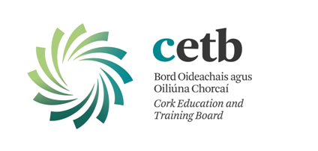

Document: | Privacy Notice Employees, Volunteers, Board Members, Committee Members etc.
Procedure No: | 2020/01
Effective Date: | 1st May 2020
Supersedes: | 2018/01
Issued By: | Corporate Services
Review Date: | As required

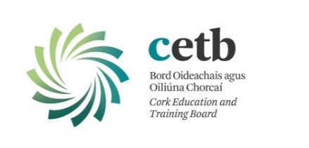

Cork Education and Training Board
Privacy Notice Employees, Volunteers, Board Members, Committee Members etc.

By applying for any position, working or volunteering with, or otherwise taking up any position within CETB, you acknowledge that your personal data (including special category personal data) shall be processed by CETB. This Privacy Notice gives you some helpful information about who we are, what personal data we collect about you, why we collect it, who we share it with and why, how long we keep it, and your rights in relation to it. If you need more information, please see our Data Protection Policy which is available at https://www.corketb.ie/about-cork-etb/organisation/corporate-governance/policies/etb-policies/

- We are Cork Education and Training Board (CETB) – a statutory body established under the Education and Training Boards Act, 2013. CETB is the data controller in relation to the processing of your personal data. Our address and contact details are:

Address: 21, Lavitt’s Quay, Cork.
Telephone: 021/4907100
Email: info@corketb.ie

We provide primary and second-level education, second chance education; further education and training (including apprenticeships); youth services, community-based education programmes; prison education, outdoor education; outreach programmes, specialist programmes eg. Music Generation and other programmes/courses as may be delivered/funded/sponsored in whole or part or in co-operation with other bodies/agencies etc. For further information, see Section 1 of our Data Protection Policy available at: https://www.corketb.ie/about-cork-etb/organisation/corporate-governance/policies/etb-policies/.

- The personal data we collect about you includes your name; date of birth; address; contact details; CV and qualifications; vetting outcome; Teaching Council registration; registration with any other professional/accrediting body; PPS number; financial data; images (staff cards, CCTV); medical, health and occupational health data; immigration/work-visa information; information relating to recruitment, promotions, and appointments processes; other IR/HR processes; pensions details etc. We use personal data for purposes including: running an efficient service; complying with our obligations as an employer; recruitment and appointments; allocating resources to our education centres; monitoring the effectiveness of our equal opportunities policies; discharging our duties to other staff and students; complying with our statutory reporting obligations to Government bodies and EU funding bodies; resolving disputes and defending litigation, etc. The information we collect about you depends on various factors, eg. we will hold differing levels of information about a job applicant as compared with a long-standing employee. Certain personal data is collected and aggregated for use on an anonymised basis, eg. to monitor our compliance with equal opportunities and non-discrimination policies. For further information on what data we collect, why we collect it, how we use it and the legal basis for same, please go to Section 2 of our Data Protection Policy available at: https://www.corketb.ie/about-cork-etb/organisation/corporate-governance/policies/etb-policies/.

- We share your personal data with third parties, including other Government bodies. Depending upon the nature of your role within CETB, this may include data-sharing with bodies including the Department of Education and Skills, Revenue Commissioners, Department of Social Protection, Comptroller & Auditor General, TUSLA, An Garda Síochána, HSE, the Teaching Council or any other regulatory body to which you belong, your Trade Union (for IR/HR issues), occupational health advisors, our insurance company (Irish Public Bodies), banks/financial institutions (to pay wages), pension administrators and pension trustees, future employers (for references etc), other service providers (including IT providers, security providers, legal advisors) etc. The Government bodies to which we transfer your personal data will use it for their own purposes (including: to verify other information they already hold about you, for fraud prevention measures, etc) and may aggregate it with other information they already hold about you. For further information on who we share your data with, when and in what circumstances, and why, please see section 3 of our Data Protection Policy available at: https://www.corketb.ie/about-cork-etb/organisation/corporate-governance/policies/etb-policies/.

- We do not envisage that any of your personal data will be transferred outside of the European Economic Area (EEA). However, we may transfer the personal data we collect about you outside of the EEA, where a trusted service provider is based in a third country or international organisation. We will always take steps to ensure that any transfer of your information outside of the EEA is carefully managed to protect your privacy rights. We do not engage in automated decision-making/profiling.

- Some personal data is kept only for a short period (eg. we will destroy at the end of an academic year if it is no longer needed). Some data we retain for a longer period (ie. we retain it even after you leave our employment). For further information on the records management retention, please see our Records Management Policy and Records Retention Schedule available at https://www.corketb.ie/about-cork-etb/organisation/corporate-governance/policies/etb-policies/.

- You have the following statutory rights, that can be exercised at any time:
- Right to complain to the supervisory authority.
- Right of access.
- Right to rectification.
- Right to be forgotten.
- Right to restrict processing.
- Right to data portability.
- Right to object to automated decision making/profiling.

For further information on how to access these rights, please see Section 7 of our Data
Protection Policy available at:
https://www.corketb.ie/about-cork-etb/organisation/corporate-governance/policies/etb-policies/, or, alternatively, contact our Data Protection Office.

7. The Data Protection Officer (DPO) for Cork ETB is Sarah Flynn. Contact details:
Email: dataprotection@corketb.ie or telephone: 021/4907100.

8. Should you wish to make a complaint or report a breach in relation to your personal data, you can do so by emailing the Office of the Data Protection Commissioner using the following email address: info@dataprotection.ie.

